EXPERIMENT - 19
STUDENT–TEACHER–SUBJECT CODE DATABASE USING PROLOG
QUESTION
Write a Prolog program to create a database containing student details, teacher details, and subject codes, and retrieve the related information using queries.
AIM
To write and execute a Prolog program to represent the relationship between students, teachers, and subject codes using facts and rules.
PROCEDURE
- Start the SWISH Prolog editor.
- Define facts for students with their IDs and names.
- Define facts for teachers with their IDs and names.
- Define facts for subjects with their subject codes and names.
- Define the relationships between teachers, subjects, and students.
- Create a rule to retrieve student, teacher, and subject information.
- Execute the program using suitable queries.
- Display the results and stop the program.
PROGRAM
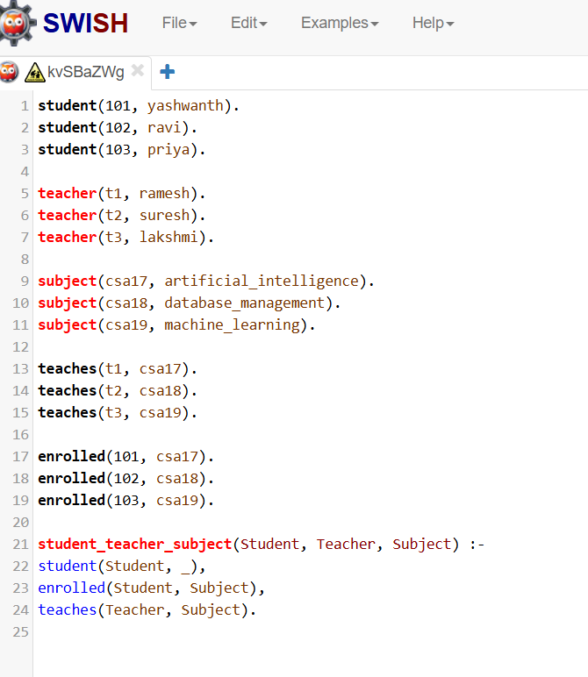

OUTPUT
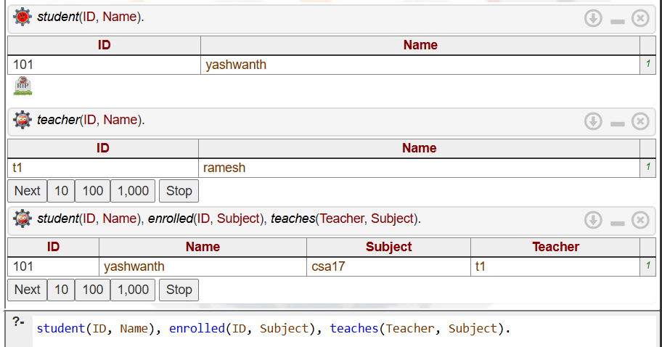

RESULT
Thus, the Prolog program to create a database of students, teachers, and subject codes and retrieve their relationships was successfully executed.

